Table of Contents

Visualizing Loss and Accuracy for a Classification Model 1

Viewing Losses for Linear Models 5

MLPClassifier and MLPRegressor from Scikit-learn 8

GridSearchCV with MLPClassifier 10

MLPRegressor 12

## Visualizing Loss and Accuracy for a Classification Model

Being able to visualize loss and accuracy during training and testing helps to understand the effectiveness of the hyperparameters. Figure 1 shows an ideal scenario for loss and accuracy for a classification model. Loss decline is smooth. The accuracy peaks at approximately 200 epochs. There is some fluctuation in accuracy. The information suggests that potentially 200 to 400 epochs are required for reaching peak performance during training with the current set of parameters. You will also notice that validation (test) sets have slightly higher losses and the tests sets are also slightly less accurate than the training sets.

Figure : Visualizing Loss and Accuracy Parameters for a Classification Model

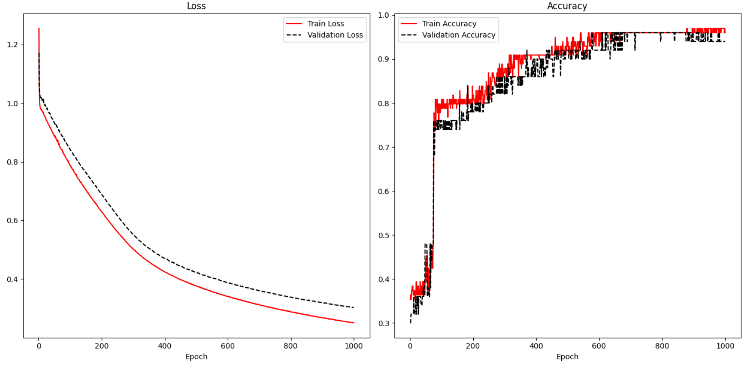

To enable display of train and validation results, validation_data arguments must be supplied in the model.fit() instruction. Note that the data has already been split into three data sets so that the model can be fit with training data and validated during training with validation data. The test data set is unseen data which is then used after the model has been trained for a final evaluation.

|  |
| --- |
| X_train, **X_temp**, y_train, **y_temp** = train_test_split(x_arrayReshaped,  y_arrayReshaped, test_size=0.3)  X_val, X_test, y_val, y_test = train_test_split(**X_temp**,  **y_temp**, test_size=0.5) |

A history variable is needed to store the loss and accuracy results.

|  |
| --- |
| history = model.fit(X_train, y_train, epochs=1000, batch_size=28, verbose=1,  validation_data=(X_val, y_val)) |

To track the accuracy of the result, metrics=['accuracy'] is included in the compile statement.

|  |
| --- |
| model.compile(optimizer='sgd', loss='sparse_categorical_crossentropy',  metrics=['accuracy']) |

Example : Visualizing Loss and Accuracy

Here is the code that is used to display the accuracy and losses in Figure 1 when fitting an iris data set prediction model. The locations where the history variable is set and referenced are highlighted to show how the losses and accuracy are tracked.

A detailed classification report shows how well the model performs with test data which the model did not see during training or validation.

|  |
| --- |
| precision recall f1-score support  0 1.00 1.00 1.00 9  1 1.00 0.89 0.94 9  2 0.88 1.00 0.93 7 |

Here is the code:

|  |
| --- |
| import pandas as pd  from sklearn.model_selection import train_test_split  from sklearn.preprocessing import LabelEncoder  from tensorflow.keras import Sequential  from tensorflow.keras.layers import Dense  PATH = "/Users/pm/Desktop/DayDocs/data/"  df = pd.read_csv(PATH + 'iris_v2.csv')  df.columns = ['Sepal L', 'Sepal W', 'Petal L', 'Petal W', 'Iris Type']  print(df)  # Convert text to numeric category.  # 0 is setosa, 1 is versacolor and 2 is virginica  df['y'] = LabelEncoder().fit_transform(df['Iris Type'])  # Prepare the data.  dfX = df.iloc[:, 0:4] # Get X features only from columns 0 to 3  dfY = df.iloc[:, 5:6] # Get X features only from column 5  ROW_DIM = 0  COL_DIM = 1  # Create vertical array of features.  x_array = dfX.values  x_arrayReshaped = x_array.reshape(x_array.shape[ROW_DIM],  x_array.shape[COL_DIM])  y_array = dfY.values  y_arrayReshaped = y_array.reshape(y_array.shape[ROW_DIM],  y_array.shape[COL_DIM])  # Split into train, validation and test data sets.  X_train, X_temp, y_train, y_temp = train_test_split(  x_arrayReshaped, y_arrayReshaped, test_size=0.33)  X_val, X_test, y_val, y_test = train_test_split(  X_temp, y_temp, test_size=0.50)  n_features = X_train.shape[COL_DIM]  # Define the model.  model = Sequential()  # Hidden layer 1 (also receives the input layer)  model.add(Dense(2, activation='relu', input_shape=(n_features,)))  # Output layer  model.add(Dense(3, activation='softmax'))  # Compile the model.  model.compile(optimizer='sgd', loss='sparse_categorical_crossentropy', metrics=['accuracy'])  # Fit the model.  history = model.fit(X_train, y_train, epochs=1000, batch_size=28, verbose=1,  validation_data=(X_val, y_val))  # Evaluate the model with unseen data.  loss, acc = model.evaluate(X_test, y_test, verbose=0)  print('Test Accuracy: %.3f' % acc)  # make a prediction  row = [5.1, 3.5, 1.4, 0.2]  yhat = model.predict([row])  print('Predicted: s (class=d)' + str(yhat))  import matplotlib.pyplot as plt  def showLoss(history):  # Get training and test loss histories  training_loss = history.history['loss']  validation_loss = history.history['val_loss']  # Create count of the number of epochs  epoch_count = range(1, len(training_loss) + 1)  plt.subplot(1, 2, 1)  # Visualize loss history for training data.  plt.plot(epoch_count, training_loss, label='Train Loss', color='red')  # View loss on unseen data.  plt.plot(epoch_count, validation_loss, 'r--', label='Validation Loss',  color='black')  plt.xlabel('Epoch')  plt.legend(loc="best")  plt.title("Loss")  def showAccuracy(history):  # Get training and test loss histories  training_loss = history.history['accuracy']  validation_loss = history.history['val_accuracy']  # Create count of the number of epochs  epoch_count = range(1, len(training_loss) + 1)  plt.subplot(1, 2, 2)  # Visualize loss history for training data.  plt.plot(epoch_count, training_loss, label='Train Accuracy', color='red')  # View loss on unseen data.  plt.plot(epoch_count, validation_loss, 'r--',  label='Validation Accuracy', color='black')  plt.xlabel('Epoch')  plt.legend(loc="best")  plt.title('Accuracy')  plt.subplots(nrows=1, ncols=2, figsize=(14,7))  showLoss(history)  showAccuracy(history)  plt.show()  from sklearn.metrics import classification_report  # Provide detailed evaluation with unseen data.  y_probability = model.predict(X_test)  import numpy as np  # Convert probability arrays to whole numbers.  # eg. [0.0003, 0.01, 0.9807] becomes 2.  predictions = np.argmax(y_probability, axis=-1)  print(classification_report(y_test, predictions)) |

Exercise (6 marks)

Starting with the following code which loads a bill fraud data set, create a neural network to predict if the bill is fraudulent. Track losses and accuracy and show the results at the end.

|  |
| --- |
| import pandas as pd  from sklearn.model_selection import train_test_split  from sklearn.preprocessing import LabelEncoder  from tensorflow.keras import Sequential  from tensorflow.keras.layers import Dense  import numpy as np  PATH = "/Users/pm/Desktop/DayDocs/data/"  df = pd.read_csv(PATH + 'bill_authentication.csv')  # Convert text to numeric category.  # 0 is setosa, 1 is versacolor and 2 is virginica  y = df['Class']  X = df  del X['Class']  ROW_DIM = 0  COL_DIM = 1  # Create vertical array of features.  x_array = X.values  x_arrayReshaped = x_array.reshape(x_array.shape[ROW_DIM],  x_array.shape[COL_DIM])  y_array = np.array(y.values)  y_arrayReshaped = y_array.reshape(len(y_array),1) |

Show the loss curve at the end when the model is finished training.

|  |
| --- |
|  |

Even if the precision, recall and accuracy are perfect, what improvement does the plot above suggest is possible?

|  |
| --- |
| The data converges very quickly suggesting that we should reduce the amount of epochs as the rest of the epochs are unnecessary |

## Viewing Losses for Linear Models

Since linear models use measures such as RMSE to judge the fit of a model, accuracy is not plotted for linear models like in Figure 1. However, the loss plot is still useful for linear models.

The loss plot on the left of Figure 2 shows a situation where overfitting occurs. The overfitting is observed when the test data suddenly demonstrates rising losses while the training losses continue to decline.

The graph at the right of Figure 2 suggests underfitting. For this case, it appears as if the minimum loss has not been reached. The model may be improved by increasing the number of epochs.

Figure : Overfitting and Underfitting

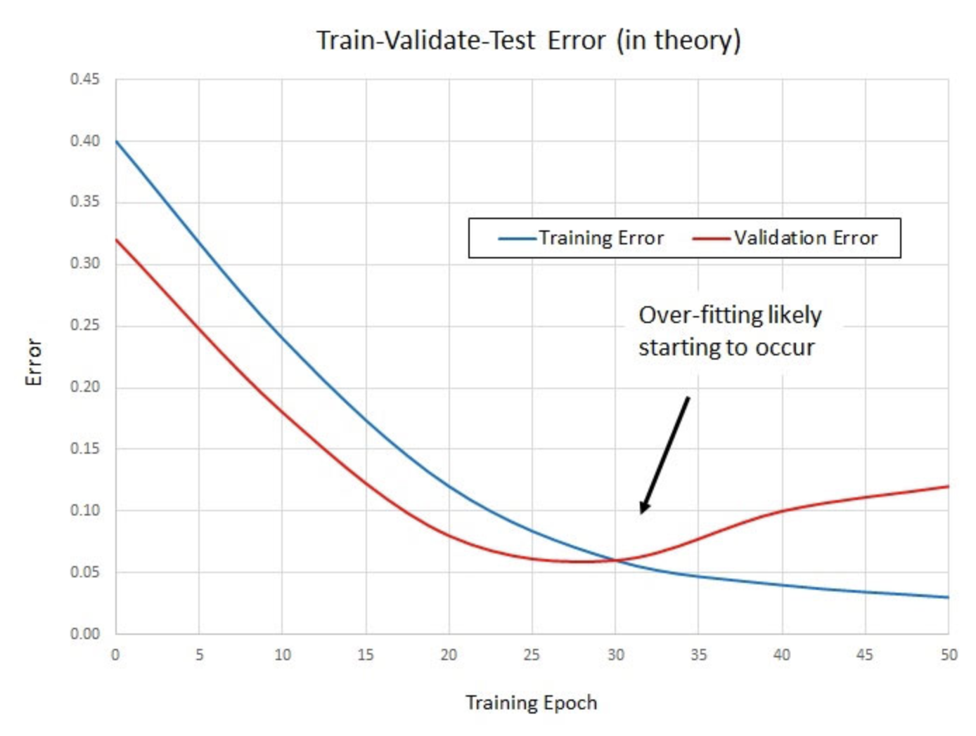 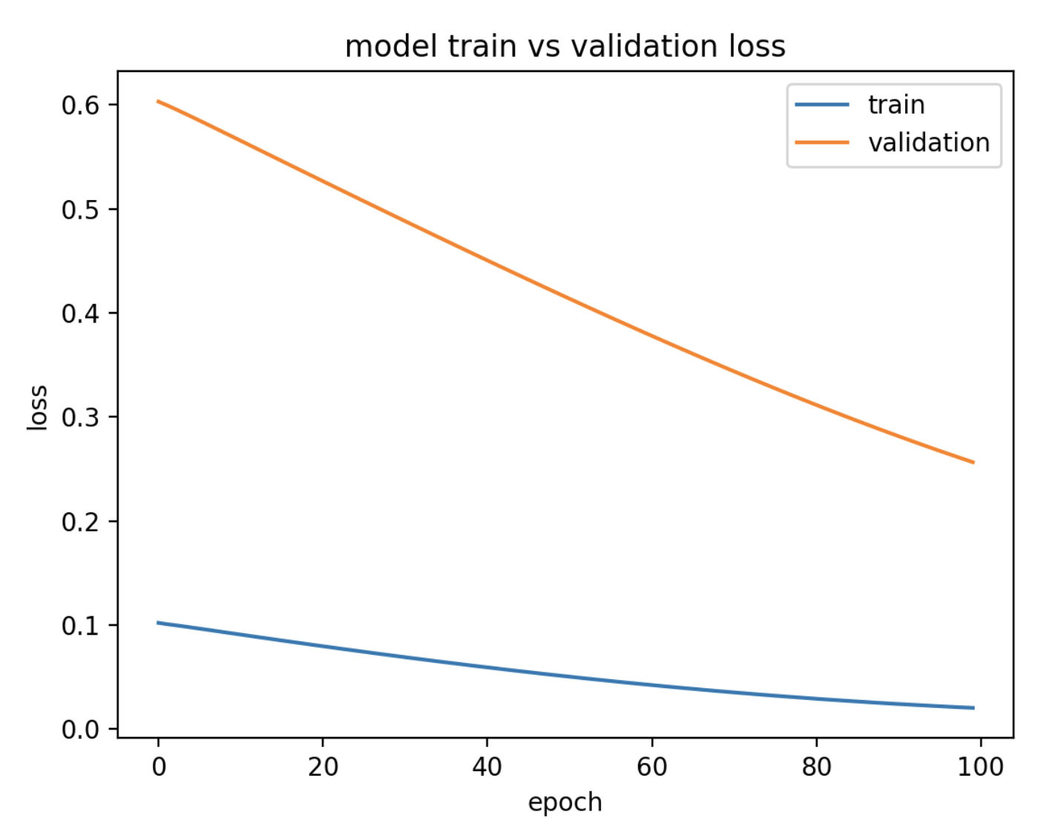

Example : Predicting Housing Price

Last day, the following code for predicting housing prices was discussed. This code implements a neural network that was previously optimized with a grid search.

|  |
| --- |
| import pandas as pd  import numpy as np  from sklearn import metrics  from sklearn.model_selection import train_test_split  from keras.models import Sequential  from keras.layers import Dense  import tensorflow as tf  # Read the data.  PATH = "/Users/pm/Desktop/DayDocs/data/"  CSV_DATA = "housing.data"  df = pd.read_csv(PATH + CSV_DATA, header=None)  # Show all columns.  pd.set_option('display.max_columns', None)  pd.set_option('display.width', 1000)  print(df.head())  print(df.tail())  print(df.describe())  # Convert DataFrame columns to vertical columns so they can be used by the NN.  dataset = df.values  X = dataset[:, 0:13] # Columns 0 to 12  y = dataset[:, 13] # Columns 13  ROW_DIM = 0  COL_DIM = 1  x_arrayReshaped = X.reshape(X.shape[ROW_DIM], X.shape[COL_DIM])  y_arrayReshaped = y.reshape(y.shape[ROW_DIM],1)  # Split the data.  X_train, X_temp, y_train, y_temp = train_test_split(x_arrayReshaped,  y_arrayReshaped, test_size=0.3, random_state=0)  X_test, X_val, y_test, y_val = train_test_split(X_temp,  y_temp, test_size=0.5, random_state=0)  def baseline_model():  model = Sequential()  model.add(Dense(25, input_dim=13, kernel_initializer='uniform',  activation='softplus'))  model.add(Dense(10, kernel_initializer='lecun_uniform', activation='softplus'))  model.add(Dense(1, kernel_initializer='uniform'))  # Use Adam optimizer with the given learning rate  opt = tf.keras.optimizers.Adam(lr=0.005)  model.compile(loss='mean_squared_error')  return model    # Build the model.  model = baseline_model()  model.fit(X_train, y_train, epochs=100,  batch_size=9, verbose=1,  validation_data=(X_val, y_val))  # NEW  #loss, xss = model.evaluate(X_test, y_test, verbose=0)  predictions = model.predict(X_test)  mse = metrics.mean_squared_error(y_test, predictions)  print("Neural network MSE: " + str(mse))  print("Neural network RMSE: " + str(np.sqrt(mse))) |

Exercise (1 mark)

Explain why it does not make sense to draw an accuracy plot for the code in Example 2.

|  |
| --- |
| Regressions work with continuous values that’s why accuracy isn’t the best fit. |

Exercise (6 marks)

Plot the loss function plot that appears when the model in Example 2 is fit. Show your revised program here. Refer to Example 1 for code that plots the loss function. Show a screenshot of the loss plot here:

|  |
| --- |
|  |

It is typical for the validation data to show higher losses than the training losses because the model learns with the training data. With this in mind, explain if you think the loss function shows a reasonably good fit, underfitting or overfitting.

|  |
| --- |
| It’s a reasonably good fit as it’s not too much of a loss but still shows some slight training errors. |

## MLPClassifier and MLPRegressor from Scikit-learn

The MLPClassifier and MLPRegressor machine learning pipeline classes from scikit-learn offer

a simple and fast way to generate neural networks while hiding the details. MLP stands for multi-layer perceptron which essentially is a sequential neural network with back propagation.

Not only are the MLPClassifier and MLPRegressor useful classes from an educational perspective, they can be used for simple ANN (artificial neural network) implementations and they can also be used to explore suitable ANN parameters which could then be used with a different framework.

At a very basic level, the MLPClassifier (or MLPRegressor) can be instantiated without any parameters.

# Create and fit model.

model = MLPClassifier()

model.fit(trainX_scaled, y_train)

print(model)

# Evaluate model.

predicted_y = model.predict(testX_scaled)

The basic instantiations of these models are actually very competitive and often perform just as well as models that are developed with basic grid searching.

Example : MLPClassifier

In this example, the MLPClassifier is initialized without any parameters. The results show a reasonable learning rate and decent metrics (results will vary from run to run):

Figure : Loss Plot for MLPClassifier

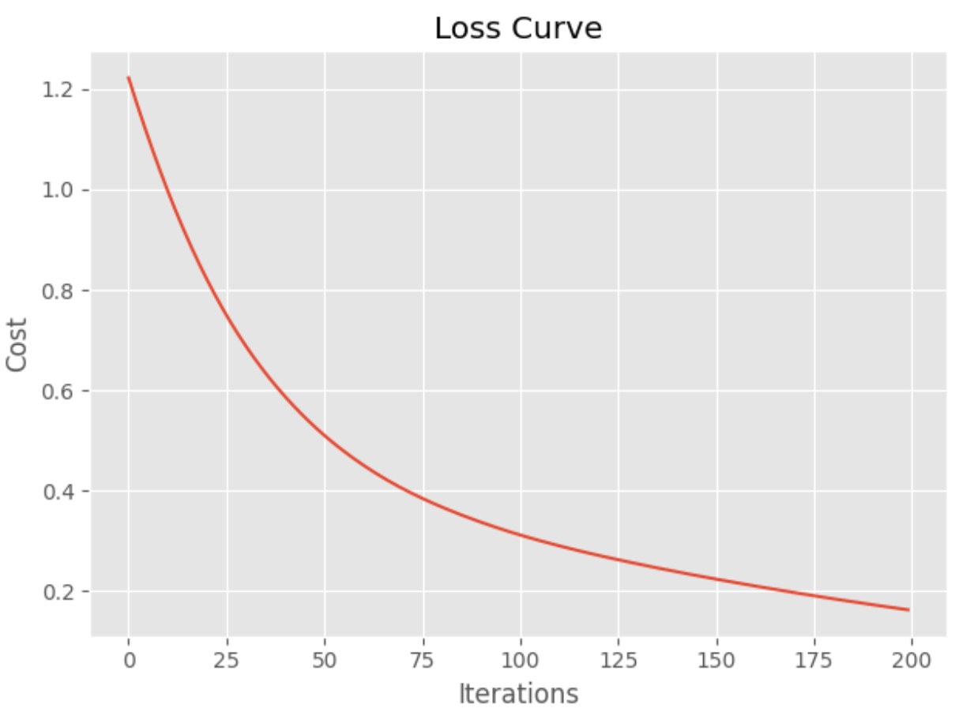

|  |
| --- |
| precision recall f1-score support  0 1.00 0.93 0.96 14  1 0.86 0.86 0.86 14  2 0.89 0.94 0.91 17 |

The default model often is very competitive with grid searched models. When the model is fitted, the parameters of the model can be displayed with the get_params() function.

|  |
| --- |
| print(model.get_params()) |

These are the parameters that were chosen for the default instantiation. You will notice some parameters such as warm_start, early_stopping, and momentum which we will talk about in a future lesson.

|  |
| --- |
| {'activation': 'relu', 'alpha': 0.0001, 'batch_size': 'auto', 'beta_1': 0.9, 'beta_2': 0.999, 'early_stopping': False, 'epsilon': 1e-08, 'hidden_layer_sizes': (100,), 'learning_rate': 'constant', 'learning_rate_init': 0.001, 'max_fun': 15000, 'max_iter': 200, 'momentum': 0.9, 'n_iter_no_change': 10, 'nesterovs_momentum': True, 'power_t': 0.5, 'random_state': None, 'shuffle': True, 'solver': 'adam', 'tol': 0.0001, 'validation_fraction': 0.1, 'verbose': False, 'warm_start': False} |

Here is the code for the example:

|  |
| --- |
| from sklearn import metrics  from sklearn.neural_network import MLPClassifier  from sklearn.model_selection import train_test_split, GridSearchCV  import matplotlib.pyplot as plt  from sklearn.preprocessing import StandardScaler  import pandas as pd  plt.style.use('ggplot')  # Create numeric target for iris type.  dataset = pd.read_csv('/Users/pm/Downloads/iris_v2.csv')  dataset.iris_type = pd.Categorical(dataset.iris_type)  # Prepare x and y.  dataset['flowertype'] = dataset.iris_type.cat.codes  del dataset['iris_type']  y = dataset['flowertype']  X = dataset  del X['flowertype']  # Split X and y.  X_train, X_test, y_train, y_test = train_test_split(X,  y, test_size=0.30)  # Scale X and Y.  scX=StandardScaler()  scalerX = scX.fit(X_train)  trainX_scaled = scalerX.transform(X_train)  testX_scaled = scalerX.transform(X_test)  # Create and fit model.  model = MLPClassifier()  model.fit(trainX_scaled, y_train)  print(model.get_params()) # Show model parameters.  # Evaluate model.  predicted_y = model.predict(testX_scaled)  print(metrics.classification_report(y_test, predicted_y))  print(metrics.confusion_matrix(y_test, predicted_y))  def showLosses(model):  plt.plot(model.loss_curve_)  plt.title("Loss Curve")  plt.xlabel('Iterations')  plt.ylabel('Cost')  plt.show()  showLosses(model) |

### GridSearchCV with MLPClassifier

Example : Grid searching the MLPClassifier

This example shows how to fine tune and ideally improve the MLPClassifier by grid searching different parameters. The custom classification report shows good results.

|  |
| --- |
| precision recall f1-score support  0 1.00 1.00 1.00 14  1 1.00 0.93 0.96 14  2 0.94 1.00 0.97 17 |

To build this example, add the following code to Example 3. Note, the **max_iter** parameter specifies the number of **epochs**. When grid searching you will see warnings when the algorithm does not reach an optimum. My understanding is that it is not possible to eliminate these warnings because the algorithm is grid searching with a fixed set of iteration options.

We are only grid searching a subset of parameters so often the model that is built with a default initialization in Example 3 will do better.

|  |
| --- |
| parameters={  'solver': ['adam', 'sgd'],  'learning_rate': ['constant', 'adaptive', 'invscaling'],  'hidden_layer_sizes': [(200,200), (300,200), (150,150)],  'activation': ["logistic", "relu", "tanh"]  }  model2 = GridSearchCV(estimator=model, param_grid=parameters,  scoring='accuracy', # average='macro'),  n_jobs=-1, cv=4, verbose=1,  return_train_score=False)  model2.fit(trainX_scaled, y_train)  print("Best parameters: ")  print(model2.best_params_)  y_pred = model2.predict(testX_scaled)  print("Report with grid: ")  print(metrics.classification_report(y_test, y_pred))  print(metrics.confusion_matrix(y_test, y_pred))  showLosses(model2.best_estimator_) |

Exercise (2 marks)

Run the code in Example 4. Show a screenshot which displays the parameters for the best model and be sure to include the hidden_layer_sizes in the screenshot.

|  |
| --- |
|  |

Explain what the hidden_layer_sizes parameter means (do not over think this).

|  |
| --- |
| The neurons in each layer. 300 for first 200 for second |

### MLPRegressor

The MLPRegressor is the regressor version of the simplified MLP family from scikit-learn.

Example : MLP Regressor

This code fits a model for predicting house prices and evaluates a default MLPRegressor object without specifying any parameters. The results are quite good for the data set provided.

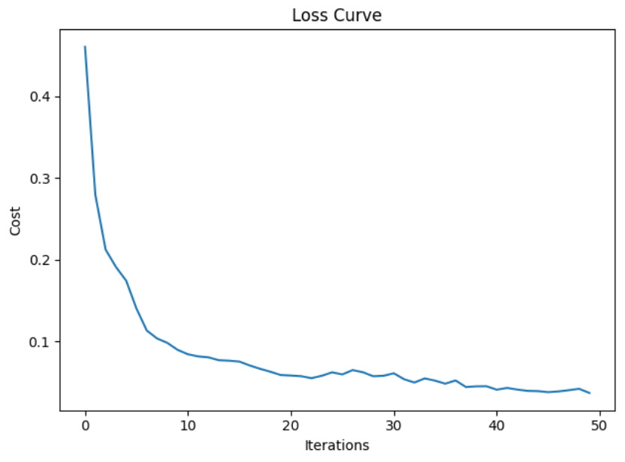

RMSE: 3.8574

|  |
| --- |
| import pandas as pd  import numpy as np  import matplotlib.pyplot as plt  from sklearn.model_selection import train_test_split  from sklearn.preprocessing import StandardScaler  from sklearn.neural_network import MLPRegressor  from sklearn import metrics  import warnings  warnings.filterwarnings(action='once')  PATH = "/users/pm/desktop/daydocs/data/"  CSV_DATA = "housing.data"  df = pd.read_csv(PATH + CSV_DATA, header=None)  # Show all columns.  pd.set_option('display.max_columns', None)  # Increase number of columns that display on one line.  pd.set_option('display.width', 1000)  print(df.head())  print(df.tail())  print(df.describe())  dataset = df.values  # split into input (X) and output (Y) variables  X = dataset[:,0:13]  y = dataset[:,13]  trainX, temp_X, trainY, temp_y = train_test_split(X, y, train_size = 0.7)  valX, testX, valY, testY = train_test_split(temp_X, temp_y, train_size = 0.5)  # Scale X and Y.  scX = StandardScaler()  scalerX = scX.fit(trainX)  trainX_scaled = scalerX.transform(trainX)  valX_scaled = scalerX.transform(valX)  testX_scaled = scalerX.transform(testX)  scY=StandardScaler()  trainY_scaled = scY.fit_transform(np.array(trainY).reshape(-1,1))  testY_scaled = scY.transform(np.array(testY).reshape(-1,1))  valY_scaled = scY.transform(np.array(valY).reshape(-1,1))  # Build basic multilayer perceptron.  model1 = MLPRegressor(  # 3 hidden layers with 150 neurons, 100, and 50.  hidden_layer_sizes = (150,100,50),  max_iter = 50, # epochs  activation = 'relu',  solver = 'adam', # optimizer  verbose=1)  model1.fit(trainX_scaled, trainY_scaled)  def showLosses(model):  plt.plot(model.loss_curve_)  plt.title("Loss Curve")  plt.xlabel('Iterations')  plt.ylabel('Cost')  plt.show()  def evaluateModel(model, testX_scaled, testY_scaled, scY):  showLosses(model)  scaledPredictions = model.predict(testX_scaled)  y_pred = scY.inverse_transform(  np.array(scaledPredictions).reshape(-1,1))  mse = metrics.mean_squared_error(testY_scaled, y_pred)  rmse = np.sqrt(mse)  print("RMSE: " + str(rmse))  evaluateModel(model1, valX_scaled, valY_scaled, scY)  # here is the new part.  param_grid = {  'hidden_layer_sizes': [(150,100,50), (120,80,40), (100,50,30)],  'max_iter': [50, 100],  'activation': ['tanh', 'relu'],  'solver': ['sgd', 'adam'],  'alpha': [0.0001, 0.05],  'learning_rate': ['constant','adaptive'],  } |

Example : Grid Searching the MLP Regressor

This example shows how to grid search the MLP Regressor parameters of the model from Example 5. It turns out that the base model tends to do a good job of fitting a neural network.

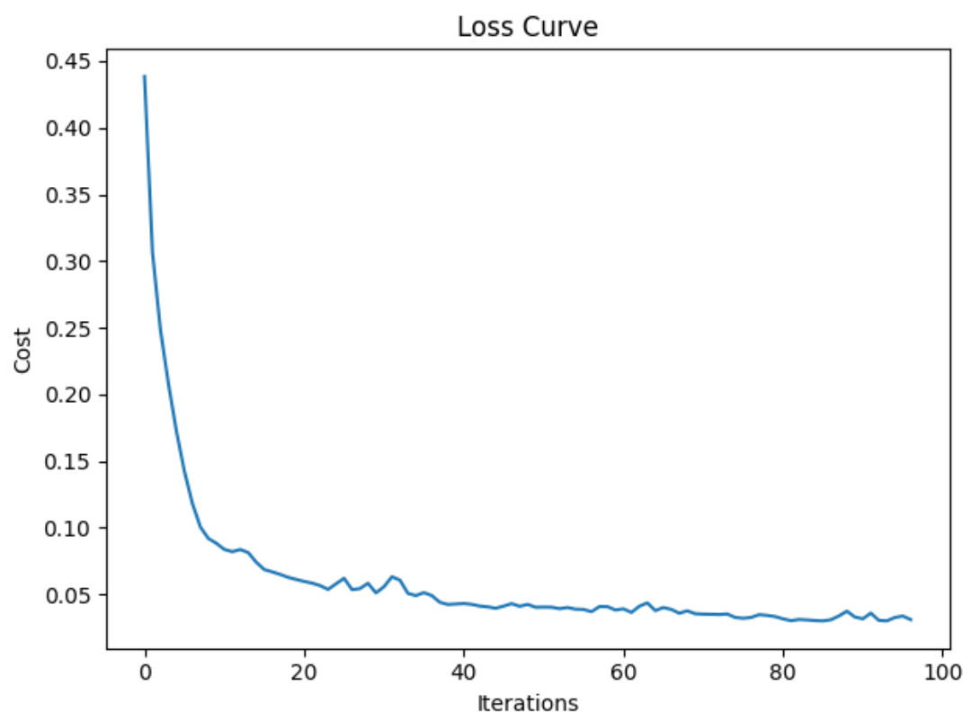

Sometimes, but not always, the grid search will find a better fit.

RMSE: 3.268

To build this example, add the following code to the end of Example 5.

|  |
| --- |
| # here is the new part.  param_grid = {  'hidden_layer_sizes': [(150,100,50), (120,80,40), (100,50,30)],  'max_iter': [50, 100],  'activation': ['tanh', 'relu'],  'solver': ['sgd', 'adam'],  'alpha': [0.0001, 0.05],  'learning_rate': ['constant','adaptive'],  }  from sklearn.model_selection import GridSearchCV  # n_jobs=-1 means use all processors.  # Run print(metrics.get_scorer_names()) for scoring choices.  model2 = MLPRegressor()  gridModel = GridSearchCV(model2, param_grid, n_jobs= -1, cv=10,  scoring='neg_mean_squared_error')  gridModel.fit(trainX_scaled, trainY_scaled)  print("Best parameters")  print(gridModel.best_params_)  evaluateModel(gridModel.best_estimator_, valX_scaled, valY_scaled, scY)  # Evaluate both models with test (unseen) data.  print("\n*** Base model with test data: ")  evaluateModel(model1, testX_scaled, testY_scaled, scY)  print(model1.get_params())  print("\n*** Grid searched model with test data: ")  evaluateModel(gridModel.best_estimator_, testX_scaled, testY_scaled, scY)  print(gridModel.get_params()) |

Exercise (2 marks)

Advanced parameter settings for learning rate provide algorithms for slowing down the learning rate as the model approaches an optimum. The scikit-learn model enables an adjusting learning rate with the ‘adaptive’ setting.

|  |
| --- |
| 'learning_rate': ['constant','adaptive'], |

Starting with Example 6, add an option to the grid search to include a range of starting learning rates. Then change the grid search so it uses a random search instead.

|  |
| --- |
| 'learning_rate_init': [0.0001, 0.001, 0.005, 0.01, 0.1, 0.2] |

Show your code here after making the changes:

|  |
| --- |
|  |

Run the random search after making the changes. Show a screenshot of the best model here.

|  |
| --- |
| These are the best parameters |
|  |